**Functional Document**

|  |  |
| --- | --- |
| **Application** | NGERP - Centra |
| **Service Bundle** | Inventory Management |
| **Service Request** | Stocktake Adjustment Authorization |

**Description :**

Stocktake adjustment Authorization screen is used by higher authorities to authorise the stock take adjustment.

After the user completes the document, the stock in the inventory is changed.

**Workflow Process :**

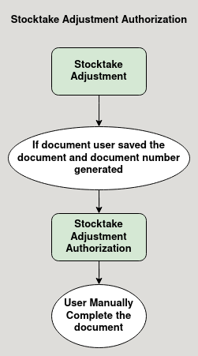

**Business Rules :**

* Stocktake adjustment authorization can be done only in region.
* It is a authorization screen for approving stock take adjustment.
* After entering details in the stock take adjustment header fields and the user saves the document, it generates the document number.
* Now the user can search for the document number in stocktake adjustment authorization screen.
* But the user cannpt able to complete the document unless the document have a line.
* Document can be completed once a line is created in the stock take adjustment screen.